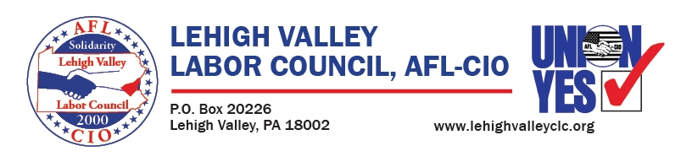

***You are Invited to Attend the 2025 Lehigh Valley Labor Council   
Annual Awards Celebration!   
Keynote Speaker   
Lamont McClure***

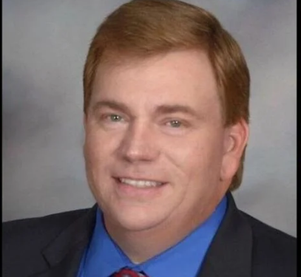

***The Northampton Memorial Community Center   
1601 Laubach Ave. Northampton Pa. Saturday, April 19, 2025   
Cocktails 5:30 – 7:00***

***Dinner at 7:00 followed by our Awards Program***

***Music by:***

***Lehigh Valley Musician of the Year***

***Jake Kaligis***

**Awards**

* ***Labor/Business Partner Dickinson Cranes***
* ***Legislator of the Year Frank Pintabone/Josh Seigel***
* ***Local of the Year TBD***
* ***Lifetime Service Award Jocelyn Lunney, Workers United***
* ***President’s Award Bob Brooks, PPFFA***
* ***William Werkheiser Award Surprise***

**Your Evening Includes:**

* ***Hors D “Oeuvres***
* ***Entertainment with the music of Jake Kaligis***
* ***Family Style Dinner***
* ***Coffee/Dessert***
* ***Open Bar for 90 Minutes***

**Pricing Options and Sponsorship Opportunities**

* **Presenting Sponsor-----$2500.00**
  + Three Tables of 8
  + Inside Cover Ad Book
  + Union/Corporate Signage at Event
  + Multiple Acknowledgements Verbal/Printed
  + Representative to Address Audience
* **Platinum Sponsor-------$2000.00**
  + Two Tables of 8
  + Full Page Ad
  + Union/Corporate Signage at Event
  + Multiple Acknowledgements Verbal/Printed
* **Diamond Sponsor-------$1500.00**
  + Table of 8
  + Full page Ad
  + Union/Corporate Signage at Event
  + Multiple Verbal/Printed Acknowledgements

Table of 8-----------$650.00-------Single Seats $80.00

**Advertising**

Inside/Outside Cover----$350.00

Full Page----------------------$275.00

Half Page---------------------$175.00

Quarter Page----------------$125.00

Please send payment to: Dennis Andrews/LVLC1705 Northampton Street, Easton PA 18042

Orders must be placed by April 11 by close of business. Color Ads are 4-1/4/by 5-1/2